The 2024 Miata ‘Amore’ Tuscany Driving Tours
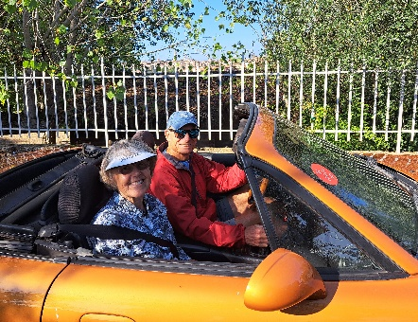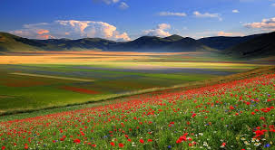
Join Blue Strada Tours in 2024 for a driving journey into the heart of Italy. Seven days driving the rolling backroads of Tuscany and Umbria, with time still to explore the quaint towns of Siena, Assisi, San Gimignano, Chianti Region, and more.
The Miata Amore Tours includes overnights in the Eternal City of Rome, 3 nights in the ‘World Heritage” city of Siena, and 3 nights just a short distance from Orvieto in Umbria. The scenic roads and rolling hills of Tuscany, Lazio and Umbria are what connect these amazing cities for 7 days. Rest assured; it is an exhilarating driving experience. Enjoying lunches and Italian coffees in small villages along the way will endear you to the rural life and culture that Italy is so famous for.
Driving Miatas in Tuscany & Umbria is made more special by adding other Miata enthusiasts from around the world. The Miata has captured the heart and soul of so many fans. Our guests have come from USA, Canada, Ireland, and Australia.
A 17th century Inn overlooking Siena will be home for additional nights while we explore more of Tuscany including beautiful historic villages and some of the most famous regions for Italian wine and of course FOOD!
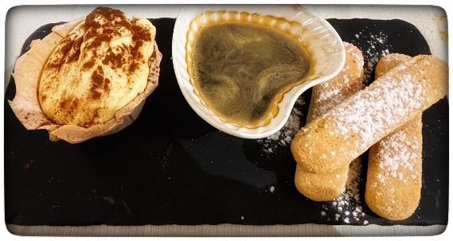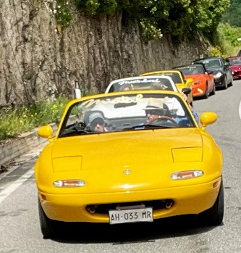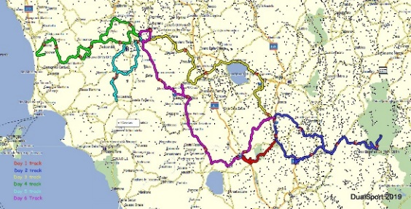
Blue Strada’s experienced Tour Leaders have spent many hours organizing the driving routes and hospitality to deliver a motoring excursion you will always remember with a smile. The Miata Amore Tour starts and ends in Rome. Expanding your visit to this fabulous city is also quite simple and rewarding to do.
Amore! The 2024 Miata Tuscany Driving Tours
Presented by: Blue Strada Tours LLC

What: 8-Day Miata Tour of Tuscany & Umbria, Italy
5 Tour Dates: May 4-12; June 1-9; Sept. 7-15; Sept. 21-29; October 5-13
Tour Starts: Rome, Italy
Hospitality: 4-Star Inns with all Breakfasts and Dinners included

Day 1: Arrival at Rome*… typically in the A.M. from North America. Relax at the hotel and enjoy the
afternoon in Rome. A “Meet &and Greet” in the late afternoon before our Welcome Dinner that evening.
We strongly suggest arriving 1-2 Days early to explore Rome and adjust to new time zone.

Day 2: After breakfast we rendezvous with our shuttle van that takes us directly to the cars; about 1 hour
from the Rome hotel. A beautiful afternoon drive to our hotel in the countryside of Umbria.

Day 3: We depart mid-morning through lovely roads in Perugia to Castelluccio di Norcia for a typical Italian lunch with beautiful view of Lentil fields before returning on another twisting alternate route.

Day 4: Our winding roads take us to the town of Assisi in Perugia. One of the ‘Best-preserved’ medieval towns in the world. Today, Assisi is a captivating small town with charm and beauty.

Day 5: More winding roads to a special lunch in Montefollonico; the wine country and beautiful Siena.

Day 6: Meet the spirals of San Gimignano and a visit to Siena’s Piazza del Campo—a medieval square in the center of Siena, famous for Palio Horse Races, and the beautiful Cathedral of Santa Maria Assunta.

Day 7: The “roofless” 13th century San Galgano Abbey, Chianti Region for a taste and more rolling hills.

Day 8: Our return to Rome is imminent. Arriving in the afternoon, the day finishes with the Tour Celebration dinner.

Day 9: Transport to Rome International airport will begin per guests’ flight schedule.

Amore! 2024 Tuscany Driving Tours
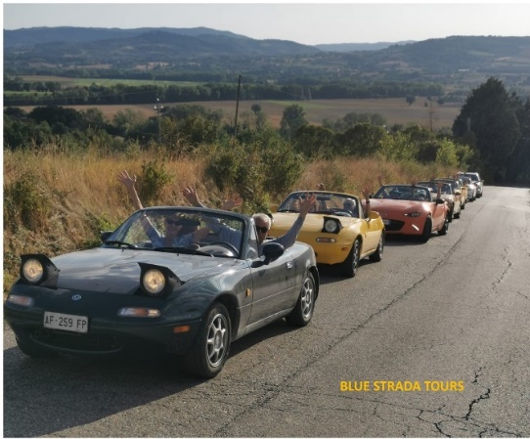
Miata Tuscany Driving Tour Includes

- A mix of Miata MX-5s (Std. Trans)
- 8-night stay in 4-star Inns or Hotels
- Tour Support Vehicle
- All Breakfasts & All Dinners
- Enthusiastic English-speaking Guides
- Airport / Hotel Limo Transfers
- All Taxes
- Primary Insurance on Vehicles
- Commemorative Apparel

The Tour Does NOT Include

- Flights to Rome
- Fuel
- Personal Expenses
- Most Lunches
- Travel Insurance

___________________________________________
2024 TOUR PRICING
2 Drivers/ 2 cars / 1 Room 2People / 1 car / 1 Room 1 Driver / 1 car / 1 Room
$5,195 per person $7,875 $5,790
**Pricing is good through June 1, 2024
For Reservations: Bill Kniegge billk@bluestradatours.com / 704 292 8801

