The Miata Amore 2020-2021 Tuscany Driving Tours
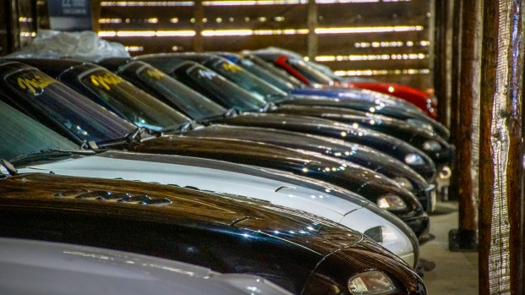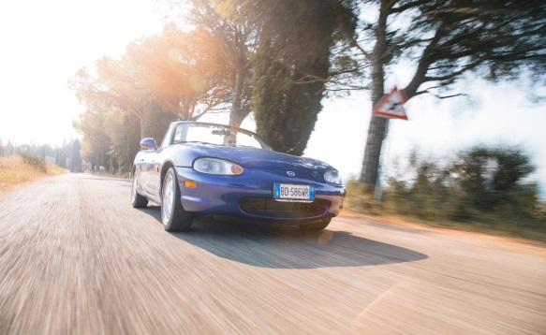
Join Blue Strada Tours in 2020 for a driving journey into the heart of Italy. Six days driving the rolling backroads of Tuscany and Umbria, with time still to explore the quaint towns of Siena, Orvieto, Montalcino, San Gimignano, Chianti Region, Pienza, Civita di Bagnoregio, and more.
The Miata Amore Tours include an overnight in the Eternal City of Rome, several nights in the ‘World Heritage” city of Siena, and 3 nights just a short distance from Orvieto in Collazzone. The scenic roads and rolling hills of Tuscany, Lazio and Umbria are what connect these amazing cities for 8 days. Rest assured, it is an exhilarating driving experience. Enjoying lunches and Italian coffees in small villages along the way will endear you to the rural life and culture that Italy is so famous for.
Andrea Mancini, an extraordinary Miata enthusiast and collector, welcomes us to Miataland—a classic Italian villa style inn that is home a personal collection of Miatas. Staying at Miataland is enjoyable in itself, but adding guests from around the world where the Miata has other enthusiastic owners makes it even more so.
A 16th century Inn overlooking Siena will be home for additional nights while we explore more of Tuscany, including beautiful historic villages and some of the most famous regions for Italian wine.
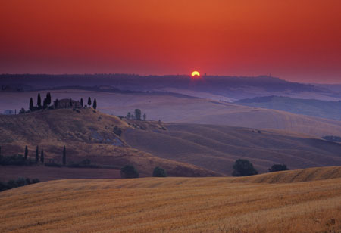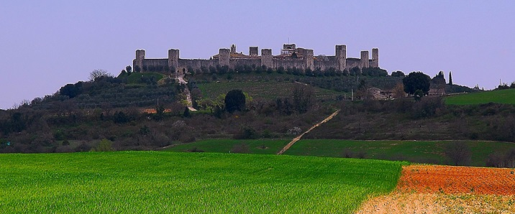
Blue Strada’s experienced Tour Leaders have spent many hours organizing the driving routes and hospitality to deliver a motoring excursion you will always remember with a smile. The Miata Amore Tour ends in Rome. Adding more days in Rome at the end of your tour is encouraged and our assistance will be available as needed.
Amore! The 2020-2021 Miata Tuscany Driving Tours
Presented by: Blue Strada Tours LLC

What: 9-Day Miata Tour of Tuscany & Umbria, Italy

Tour Starts: Rome, Italy

Hospitality: 4-Star Inns with all Breakfasts and Dinners included

- Day 1: Arrival at Rome, usually in the A.M. from North America, with plenty of time to rendezvous with the Miataland van that will take you directly to Piedecolle in beautiful Umbria where Miataland is located.
- Day 2: After breakfast and a tour of the museum, we will depart in mid-morning through lovely roads to a special destination for lunch, returning on alternate route.
- Day 3: Our route for the day takes us to interesting sights and roads in Perugia to Castelluccia di Norcia for lunch, followed by more lovely roads back to Miataland.
- Day 4: More winding roads, towards the wine country’s vistas and beautiful Siena.
- Day 5: Meet the spirals of San Gimignano and a visit to Siena’s Piazza del Campo—a medieval square in the center of Siena, famous for the Palio Horse Races held there twice each year.
- Day 6: The views of Volterra, the renowned Super Tuscan red wines of Bolgheri and the Larderello geo-thermals are on our winding route as we return to Siena.
- Day 7: More roads to love and a view of the volcano Amiata, while in Pienza. Pressing on to Orvieto, another beautiful hilltop Tuscan city.
- Day 8: Our Miataland shuttle returns the group to Rome by mid-day, allowing guests time to see why Rome is so special. And, finally, our Tour Celebration dinner.
- Day 9: Transport to Rome International airport will begin per guests’ flight schedule.
****At the end of your Tour, consider adding more days visiting Rome; our assistance will be available as needed.

Amore! Miata 2020-2021 Tuscany Tours
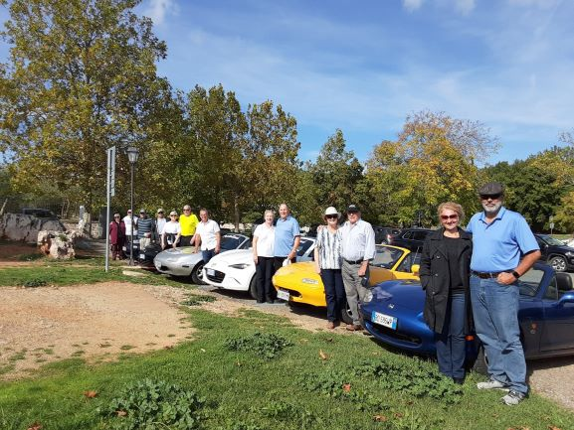
Miata Tuscany Tour Includes:
- A variety of Miata MX-5s with manual transmission
- 8-night accommodations in 4 Star Inns or Hotels

- Tour Support Vehicle
- All Breakfasts
- All Dinners
- English-Speaking Tour Guides
- Airport Transfers
- All Taxes
- Primary Insurance on Vehicles

The Tour Does NOT Include:
- Flights to Rome ٠ Lunches & ‘Adult’ Beverages
- Fuel & Tolls ٠ Travel Insurance
- Personal Expenses
____________________________________________________________________
TOUR PRICING
2 Drivers/2 Cars/ 1 Room 2 people/ 1 car/1 Room 1 Driver/1 car/1 Room
$3,875 per person $6,235 $4,360
For Reservations Contact: billk@bluestradatours.com, 1 704 292 8801

