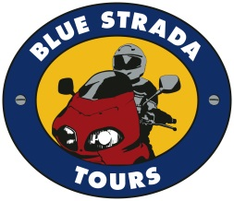
Portugal’s Exciting Roads, Amazing Scenery, and 4 Star Hospitality make this a truly extraordinary Motorcycle Touring holiday.

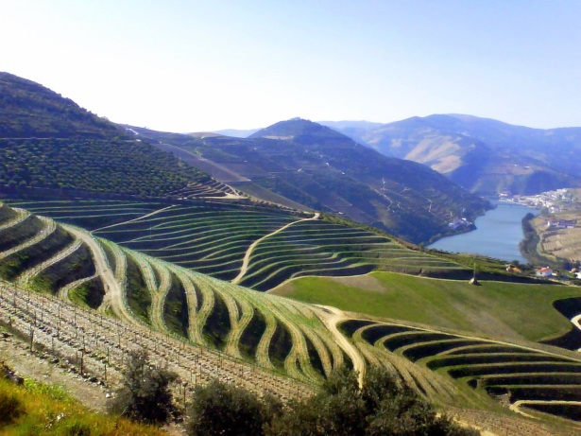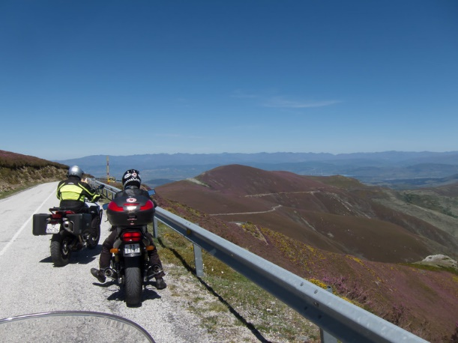

What: 9-Day Motorcycle Tour of Northern Portugal & Spain
When: September 25 – October 4, 2020 May 7 – 16, 2021
Bike Choices: BMW, Honda, Royal Enfield Himalayan, Yamaha
Accommodations: 4 Star or above; All Breakfasts & Dinners are Included.
Prices: Solo riders start at $3,650. Couples from $6,475.

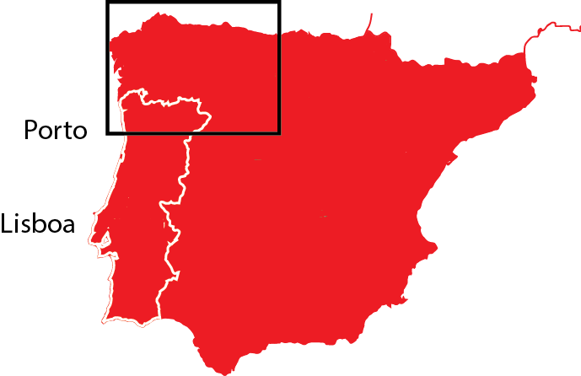
This Blue Strada Tour Includes:
Motorcycle, Tour Guides, 4-Star Lodging, Support Vehicle, All Breakfasts & Dinners
For Tour Reservations, More Details & Any Questions
billk@bluestradatours.com 704.292.8801

This unique tour of the northern Iberian Peninsula starts with the Douro Valley—and its centuries-old hillside vineyards—and eventually delivers us to Cape Finisterre. In Roman times, Cape Finisterre was believed to be the “end of the known world.” Along the way we visit The Peneda-Gerês National Park, which is the first and only protected area to be established in Portugal. Its rugged hills are home to deer, wolves and golden eagles and beautiful waterfalls. Our road also takes us to the snowy peaks of the Picos de Europa National Park—the first National Park in Spain and also a designated UNESCO Biosphere Reserve. The historic cities of León, Oviedo and Santiago de Compostela are on our route, as is the scenic Costa da Morte—so named because there have been so many shipwrecks along its treacherous rocky shore.

Day 1: Welcome to Porto, Portugal! Meet your bike and new friends.

Day 2: The ever-beautiful Douro River Valley awaits your riding spirit. 150 mi.
Day 3: Sensational Douro Valley riding to Braganca at Spain’s border. 150 mi.
Day 4: More exciting roads to scenic and fascinating León. 155 mi.
Day 5: Scenic mountain roads from León to Cangas de Onís. 150 mi.
Day 6: A “free-day” with a planned loop-ride returning to Cangas de Onís. 140 mi.
Day 7: Leave the mountains for the beautiful north coastline to Coruña. 235 mi.
Day 8: Coruña to “end of the earth” at Finisterra; and S. de Campostela. 180 mi.
Day 9: Santiago de Campostela to Generes Park and on to Porto. 190 mi.
Day 10: Depart Porto for home or another adventure.

Let’s Ride Portugal & Spain!
Presented by
Blue Strada Tours

What: 10-Day Motorcycle Tour of Northern Portugal & Spain
When: September 25 – October 4, 2020 May 7 – 16, 2021
Hospitality: 4 Star Hotels* or above; All Breakfasts & Dinners Included.
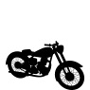
___________________________________________________________________________
Royal Enfield Himalayan $3,650 N/A
Honda NC 750 X $3,885 $6,475
BMW 750 GS $3,995 $6,675
Yamaha Ténéré 700 $3,995 $6,675
Honda Africa Twin $4,250 $6,875
BMW R1250 GS/LC $4,385 $6,990
BMW R1250 RT/LC $4,450 $7,250
*Single Room Supplement: $ 640
* Shared double room (Final Pricing: 11/1/19)
The Tour Includes:
Motorcycle with 3 cases • 9 Nights in 4 Star Hotels* • All Breakfasts & Dinners • Wine Cellar Visit & Tasting • Motorcycle Insurance and All Taxes • Support Van for luggage and shopping • English Speaking Tour Guides ٠ Tour Route Book
The Tour does not Include:
Flights & Transfers • Lunches • Personal Expenses • Fuel & Tolls • Travel Ins.

For Tour Reservations, More Details & Any Questions
Please Contact: Billk@bluestradatours.com • 1-704 292 8801

