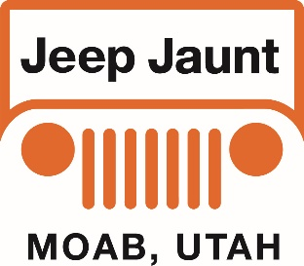
Let’s go Jeepin’ in Moab!
Presented by: Blue Strada Tours & Bill Burke

What: 7-Day Jeep 4WD Tour of Moab, Utah and surroundings
When: October 14--20, 2022
Hospitality: “Character” & Classy Lodging. All Meals included

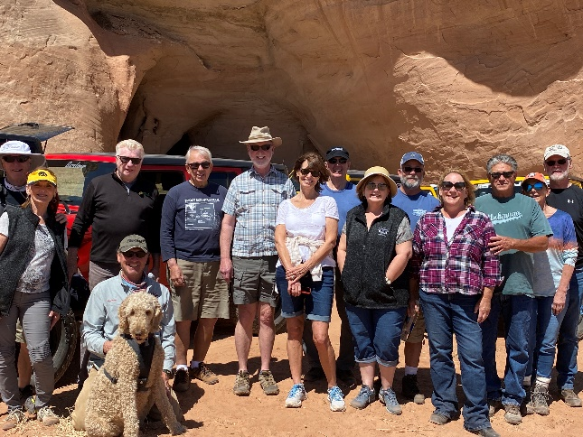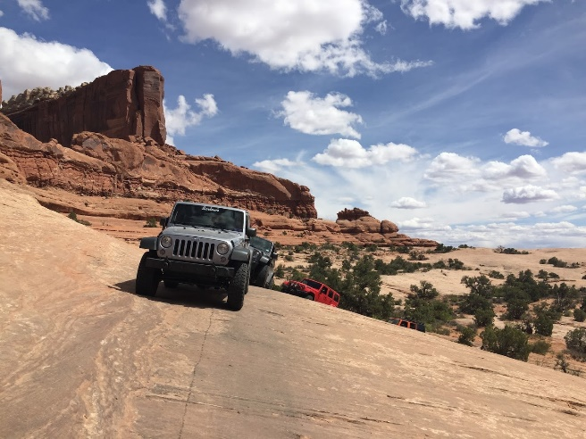

Moab, Utah is one of the most amazing places to visit in the entire USA. It is the gateway to the dramatic red rock formations of Arches and Canyonlands National Parks—vistas so specifically associated with this part of the country one might only get a chance to see them by plane, far overhead. You might even recognize some of this spectacular scenery as it was the backdrop for many John Wayne movies.
Like our tours to Italy and Portugal, finding the best local specialist to help organize and lead a custom tour experience is key. And this tour is no exception! Bill Burke, internationally recognized for his expertise as a trainer of, among other things, 4WD driving techniques and land navigation, will be our guide for this 5-day tour in a part of the country he knows so well.
Jeep Jaunt Itinerary Oct 14—20, 2022

Oct 14 – Arrive Gonzo Inn; 100 West 200 South St. Moab, UT
Pick Up Jeeps in late afternoon.
5:30-- “Meet & Greet” at Hotel Patio / Lobby area.
6:45--Jeep Jaunt “Welcome to Moab Dinner”
Oct 15* – Dome Plateau – highway along Co River, gets into high country east of Arches and north of the river. Good viewing areas, moderate to challenging route. Returns via highway (river road). Dinner at the Red Cliffs Lodge which has a winery and a Movie Museum with lots of western stuff.
Oct 16* - 7 Mile Rim – just north of Moab. Fun scenic run with a sandy wash in the beginning and some slick rock sections. Visit Uranium Arch and travel around Monitor and Merrimack Buttes. The Blanding drive will be scenic highway – very straight drive south.
Oct 17* – (Blanding start) – Comb Ridge road AKA: Posey’s Trail drops down into Comb wash. Visit an ancient Ruin structure in Arch Canyon. Follow Dog Tanks road along the original route of the Mormon Emigrant trail to connect with more ruins (interpretive site) then head to a cliff dwelling that we can visit. A short scramble to leave the canyon rim!!! Back to hotel depending on time etc.
Oct 18* – Take a “touristy” route back to Moab which will connect to the highway. From Blanding to Monticello, west into the Abajo mountains (paved) and a short forest track into an Aspen grove (if no snow). Will make a scenic with interpretive signs and quite spectacular views. Drop down into a small canyon and visit Newspaper Rock Interpretive site. (toilets there). Then back to US 191 and back to Moab. Newspaper Rock is close to Needles Area. This will be a nice, more relaxed day.
Oct 19* – “Free day” – shop, explore, bike, raft, and more. Seriously consider Arches NP or Dead Horse Point. Or, an easy ‘Jeep’ track into Tower Arch Road. The trail goes past more Dinosaur Tracks (look for the sign) and then you will be warmed up for more trails. The short hike to Tower Arch is fun and kind of a scramble, but you can also just view it from the small parking area.
Many other options are available including a Uni-Mog tour of the “Hell’s Revenge” trail that is exciting—with great views and history. The guests just hold on and enjoy the ride. More ideas can be discussed during our 4 days together.
At the end of the day, a very nice Tour Celebration Dinner in Moab.

Oct 20* – Breakfast at hotel and then airport transfer, back to Grand Junction / Moab as required by departures.
- *Morning departures are typically 9:00 or as advised.
- Afternoon arrivals should leave time to relax before dinner.

The Tour Includes:
Expert & Professional Guides ٠ Upgraded Jeep 4x4 with Primary Insurance ٠6 nights in “specialty” hotels ٠
All Breakfasts, Lunches and Dinners ٠ Tour Commemorative ٠Airport Transfers.

The Tour does NOT Include:
Flights ٠ Adult Beverages ٠Personal Expenses ٠Fuel ٠Travel Insurance.
______________________________________________________________
Tour Pricing
2 Guests /2 Jeeps / 1 Rm. 2 Guests / 1 Jeep / 1 Room 1 Guest / 1 Jeep / 1 Room
$4,210 per person $3,175 per person $4,650

Reservations and Info: Bill Kniegge @ 1-704-292-8801 email: billk@bluestradatours.com

