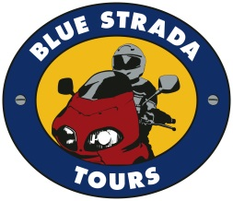
Portugal & Spain’s Exciting Roads, Amazing Scenery, and 4-Star Hospitality make this an extraordinary Motorcycle Touring holiday.

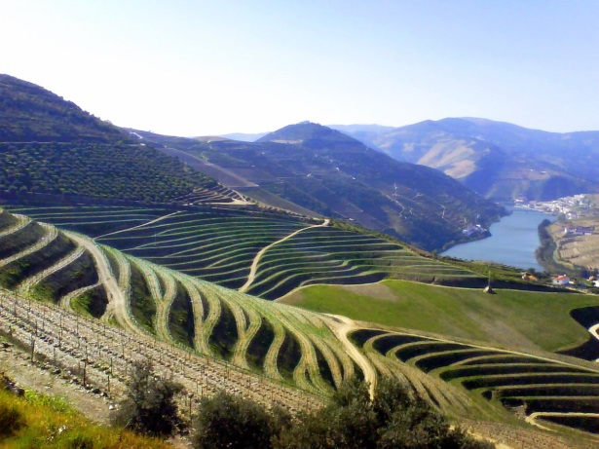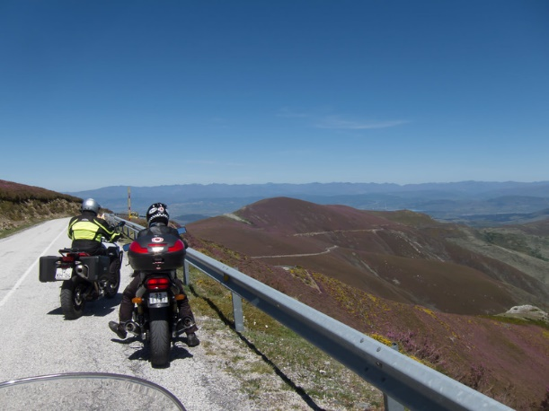

What: 10-Day Moto Tour of Portugal & Spain: 8 days Riding.
When: June 17—26, 2022
Bike Choices: BMW, Honda, Yamaha
Hospitality: 4-Star Hotels; All Breakfasts & Dinners are Included.
Prices: Solo riders start at: $4,175 Couples from: $7,250

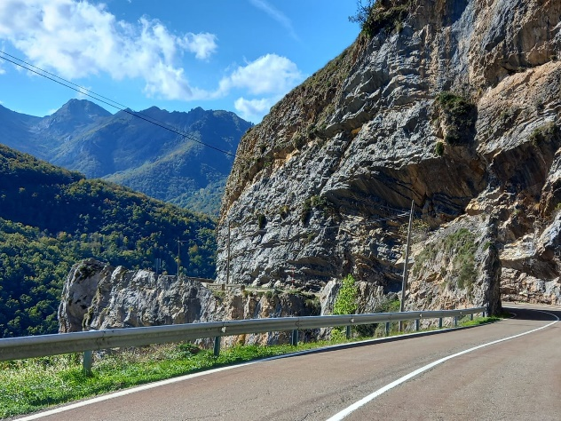
This Blue Strada Tour Includes:
Motorcycle, Tour Guides, 4-Star Lodging, Support Vehicle, All Breakfasts & Dinners
For Tour Reservations, More Details & Any Questions
billk@bluestradatours.com 704.292.8801

This unique tour of eastern Portugal & Spain starts with the Douro Valley and its centuries-old hillside vineyards, eventually delivering us to Serra da Estrela. In route to Braganca, we become part of its rugged hills that are home to deer, wolves, golden eagles, and beautiful waterfalls. A Free-Day in Avila lets some explore the 11th century medieval walls surrounding the city. In route to the highest mountain range in Portugal—Serra da Estrela—we encounter the famous cork trees of Monte Valcorchero.
Serra da Estrela Mountains
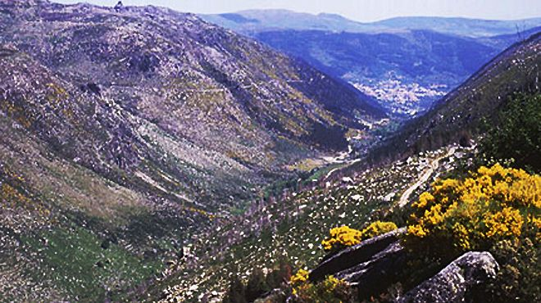

Day 1: Welcome to Porto, Portugal! Meet your bike and new friends.
Day 2: The ever-beautiful Douro River Valley awaits your riding spirit. 160 mi.
Day 3: Sensational riding from Spain’s border to Torre de Moncorvo. 160 mi.
Day 4: More exciting roads to scenic Salamanca. 155 mi.
Day 5: Scenic Mountain views to Avila. 180 mi.
Day 6: A ‘Free-Day’ with a terrific ‘loop’ ride returning to Avila. 130 mi.
Day 7: Leave the mountains for the historic Plasencia. 155 mi.
Day 8: More mountain beauty to Serra da Estrela. 165 mi.
Day 9: Serra da Estrela to Porto. 155 mi.
Day 10: Depart Porto for home or another adventure.

Let’s Ride Portugal & Spain!
Presented by
Blue Strada Tours

What: 10-Day Motorcycle Tour of Portugal & Spain
When: June 17—26, 2022
Hospitality: 4-Star Hotels* All Breakfasts & Dinners Included.
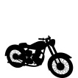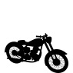
___________________________________________________________________________
Royal Enfield Interceptor $4,175 N/A
Honda CB 500X $4,225 $7,250
BMW 750 GS $4,395 $7,450
Yamaha Ténéré 700 $4,555 $7,550
BMW R1250 GS/LC $4,725 $7,850
Husqvarna 901 Norden TBD TBD
Ducati Multistrada 950 TBD TBD
*Single Room Supplement: $ 675
* Shared double room (Pricing: 12/7/2021)
The Tour Includes:
Motorcycle with 3 cases • 9 Nights in 4-Star Hotels* • All Breakfasts & Dinners • Wine Cellar Visit & Tasting • Motorcycle Insurance and All Taxes • Support Van for luggage and shopping • English Speaking Tour Guides ٠ Tour Route Book
The Tour does not Include:
Flights & Transfers • Lunches • Personal Expenses • Fuel & Tolls • Travel Insurance

For Tour Reservations, More Details & Any Questions
Please Contact: Billk@bluestradatours.com • 1-704 292 8801

