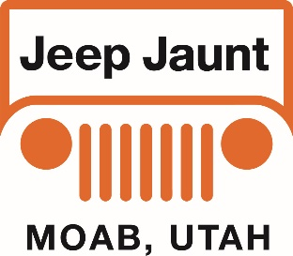
Let’s go Jeepin’ in Moab!
Presented by: Blue Strada Tours & Bill Burke

What: 7-Day Jeep 4WD Tour of Moab, Utah and surroundings
When: October 26—November 1, 2022
Hospitality: “Character” & Classy Lodging. All Meals included

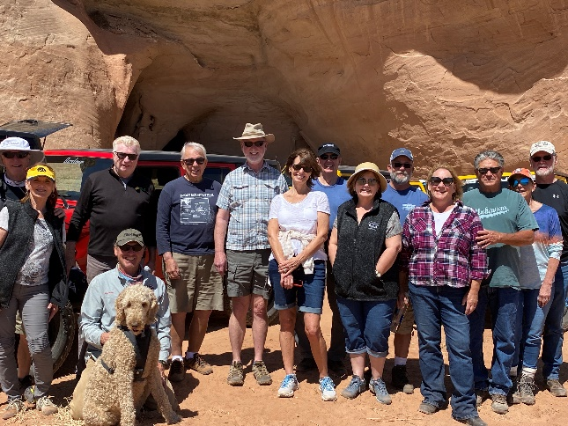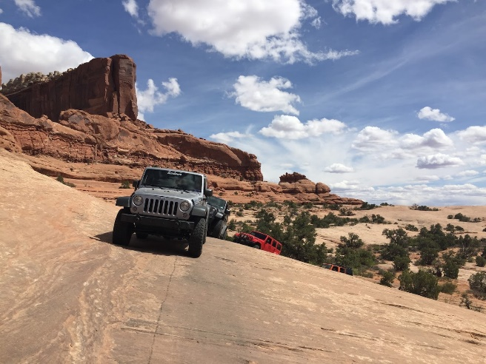

Moab, Utah is one of the most amazing places to visit in the entire USA. It is the gateway to the dramatic red rock formations of Arches and Canyonlands National Parks—vistas so specifically associated with this part of the country one might only get a chance to see them by plane, far overhead. You might even recognize some of this spectacular scenery as it was the backdrop for many John Wayne movies.
Like our tours to Italy and Portugal, finding the best local specialist to help organize and lead a custom tour experience is key. And this tour is no exception! Bill Burke, internationally recognized for his expertise as a trainer of, among other things, 4WD driving techniques and land navigation, will be our guide for this 5-day tour in a part of the country he knows so well.
Jeep Jaunt Itinerary Oct 26-Nov 1, 2022

Oct 26 – Arrive Aarchway Inn; 1551 N Riverview Dr, Moab, Utah
- Pick Up Jeeps in late afternoon.
5:30-- “Meet & Greet” at Hotel Patio
6:45--Jeep Jaunt “Welcome to Moab Dinner”
Oct 27* – Dome Plateau – highway along Co River, gets into high country east of Arches and north of the river. Good viewing areas, moderate to challenging route. Returns via highway (river road). Dinner at the Red Cliffs Lodge which has a winery and a Movie Museum with lots of western stuff. Overnite in Monticello.
Oct 28* - A Bill Burke “Special Adventure” of Scenery and Excitement
Oct 29* –Comb Ridge road AKA: Posey’s Trail drops down into Comb wash. Visit an ancient Ruin structure in Arch Canyon. Follow Dog Tanks road along the original route of the Mormon Emigrant trail to connect with more ruins (interpretive site) then head to a cliff dwelling that we can visit. A short scramble to leave the canyon rim!!! Overnite at Stone Lizard Lodge; Blanding UT.
Oct 30* – Bill Burke’s Adventure Day #2 of Scenery, Challenges and Excitement.
Oct 31* – Taking a meandering route back to Moab via Monticello, and west to the Abajo Mountains through forestry to an Aspen grove weather permitting. Then to more spectacular views on the way to Newspaper Rock Interpretive site. (Toilets here). Arriving back to Moab just after 12:00 Noon… with a free afternoon to explore Moab or more trails. Arches National Park and Dead Horse Point are certainly worth considering for a visit. More ideas can be discussed during our 5 days together. Finally…At day’s end a very nice Tour Celebration Dinner in Moab.
Nov 1* – Breakfast at hotel and then “Until We Meet Again”… We’ll begin airport transfers, back to Grand Junction / Moab as required by departures.
- *Morning departures are typically 9:00 or as advised.
- Afternoon arrivals normally leave time to relax before dinner.

The Tour Includes:
Expert & Professional Guides ٠ Upgraded Jeep 4x4 with Primary Insurance ٠6 nights in “specialty” hotels ٠
All Breakfasts, Lunches and Dinners ٠ Tour Commemorative ٠Airport Transfers.

The Tour does NOT Include:
Flights ٠ Adult Beverages ٠Personal Expenses ٠Fuel ٠Travel Insurance.
______________________________________________________________
Tour Pricing
2 Guests /2 Jeeps / 1 Rm. 2 Guests / 1 Jeep / 1 Room 1 Guest / 1 Jeep / 1 Room
$4,470 / per person $3,365 / per person $4,980

Reservations and Info: Bill Kniegge @ 1-704-292-8801 email: billk@bluestradatours.com

