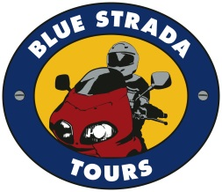
Portugal & Spain’s Exciting Roads, Amazing Scenery, and 4-Star Hospitality make this an extraordinary Motorcycle Touring holiday.

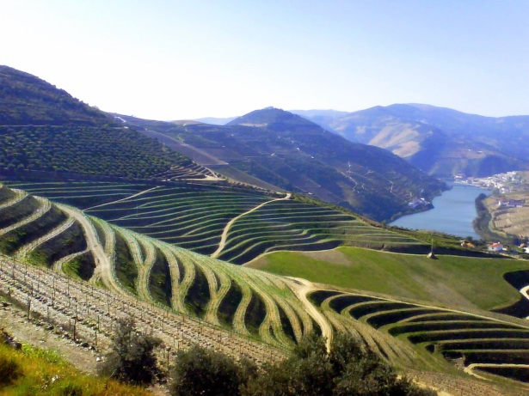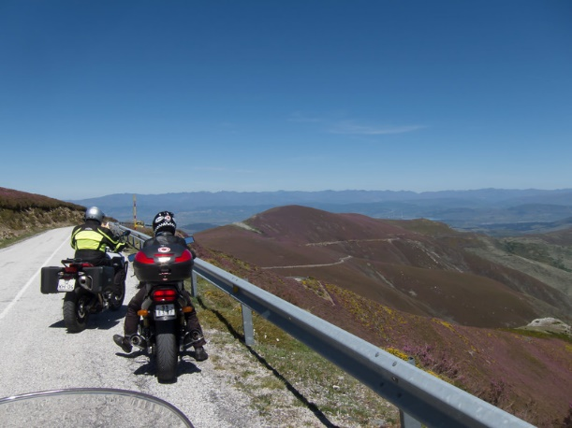

What: 10-Day Moto Tour of Portugal & Spain: 8 days Riding.
When: May 19—28, 2023
Bike Choices: BMW, Honda, Yamaha, Husqvarna, Royal Enfield, as available.
Hospitality: 4-Star Hotels; All Breakfasts, Dinners & Transfers are Included.
Prices: Solo riders start at: $4,575 Couples from: $7,595

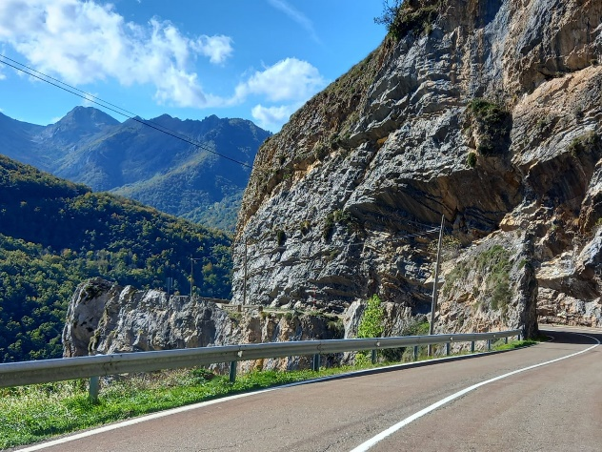
This Blue Strada Tour Includes:
Motorcycle, Tour Guides, 4-Star Lodging, Support Vehicle, All Breakfasts & Dinners
For Tour Reservations, More Details & Any Questions
billk@bluestradatours.com 704.292.8801

This unique tour of eastern Portugal & Western Spain starts with the Douro Valley and its centuries-old hillside vineyards, eventually delivering us to Pinhao. In route Torre de Moncorvo, we become part of its rugged hills that are home to deer, wolves, golden eagles, and beautiful waterfalls. A Free-Day in Avila lets some explore the 11th century medieval walls surrounding the city. In route to the highest mountains in Portugal—Serra da Estrela—we encounter the famous cork trees of Monte Valcorchero.

Douro River Valley
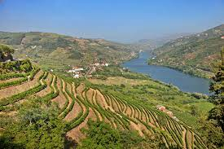

Day 1: Welcome to Porto, Portugal! Meet your bike and new friends.
Day 2: The ever-beautiful Douro River Valley awaits your riding spirit. 160 mi.
Day 3: Sensational riding from Spain’s border to Torre de Moncorvo. 160 mi.
Day 4: More exciting roads to scenic Salamanca. 155 mi.
Day 5: Scenic Mountain views to Avila. 180 mi.
Day 6: A ‘Free-Day’ with an optional ‘loop’ ride returning to Avila. 130 mi.
Day 7: Leave the mountains for the historic Plasencia. 155 mi.
Day 8: More mountain beauty to Serra da Estrela. 165 mi.
Day 9: Serra da Estrela to Porto. 155 mi.
Day 10: Depart Porto for home or another adventure.
A Motorcycle Adventure of Lifetime
Presented by
Blue Strada Tours

What: 10-Day Motorcycle Tour of Portugal & Western Spain
When: May 19—28, 2023
Hospitality: 4-Star Hotels; All Breakfasts, Dinners & Transfers are Included.
Prices: Solo riders start at: $4,525 Couples from: $7,550

MOTORCYCLES
Early Rez =_Best Choices SOLO 2-UP
Royal Enfield Interceptor $4,525* $7,475
Honda CB 500X $4,575* $7,600
BMW 750 GS $4,650* $7,750
Yamaha Ténéré 700 $4,785* $7,895
BMW R1250 GS/LC $4,875* $8,175
Husqvarna 901 Norden $4,875* $8,175
Single Room Supplement $ 685
*Shared Double Room ( Pricing good thru 12/30/22)
The Tour Includes:
Motorcycle with 3 cases • 9 Nights in 4-Star Hotels* • All Breakfasts & Dinners • Airport Transfers • Wine Cellar Visit & Tasting • Motorcycle Insurance and All Taxes • Support Van for luggage and shopping • English Speaking Tour Guides ٠ Tour Route Book • Tour Commemorative Memento.

The Tour does not Include:
Flights • Lunches • Personal Expenses • Fuel & Tolls • Travel Insurance • Gratuities
For more Details & questions: Contact: Billk@bluestradatours.com • 1-704 292 8801

