The 2024 Miata ‘Amore’ Tuscany Driving Tours
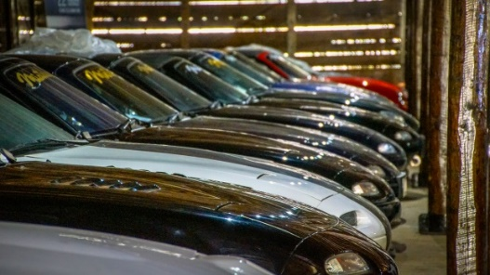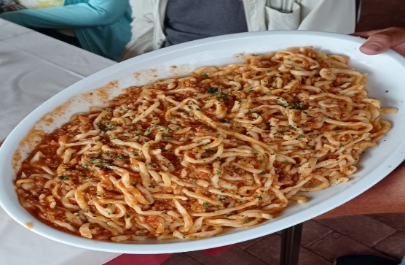
Join Blue Strada Tours in 2024 for a driving journey into the heart of Italy. Six (6) days driving the rolling backroads of Tuscany and Umbria, with time still to explore the quaint towns of Siena, Orvieto, Montefollonico, San Gimignano, Chianti Region, Pienza and more.
The Miata Amore Tours include an overnight in the Eternal City of Rome, several nights in the ‘World Heritage” city of Siena, and three (3) nights just a short distance from Orvieto in Collazzone. The scenic roads and rolling hills of Tuscany, Lazio and Umbria are what connect these amazing cities for eight (8) days. Rest assured; it is an exhilarating driving experience. Enjoying lunches and Italian coffees in small villages along the way will endear you to the rural life and culture that Italy is so famous for.
Andrea Mancini, an extraordinary Miata enthusiast and collector, welcomes us to Miataland—a classic Italian villa style Inn that is home to a personal collection of Miatas. Staying at Miataland is enjoyable in itself, but adding guests from around the world where the Miata has other enthusiastic owners makes it even more so.
A 16th century Inn overlooking Siena will be home for additional nights while we explore more of Tuscany--including beautiful historic villages and some of the most famous regions for Italian wine. 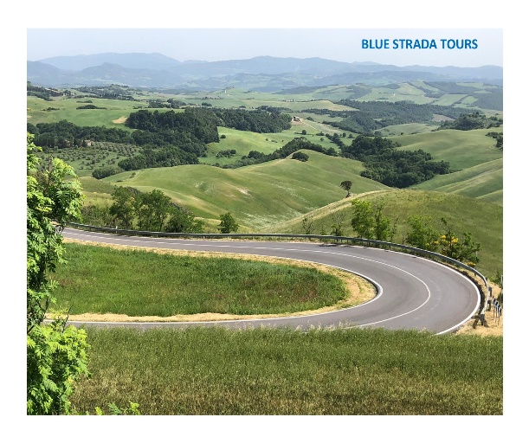 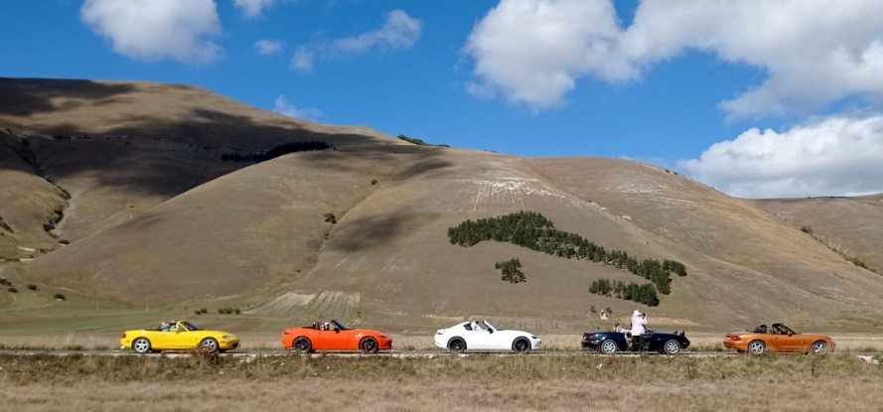
Blue Strada’s experienced Tour Leaders have spent many hours organizing the driving routes and hospitality to deliver a motoring excursion you will always remember with a smile. The Miata Amore Tour ends in Rome. Adding more days in Rome at the end of your tour is encouraged and our assistance will be available as needed.
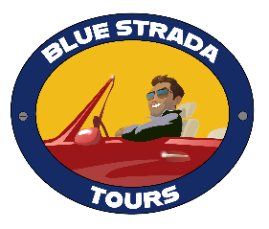
Amore! The 2024 Miata Tuscany Driving Tours

What: 8-Day Miata Driving Tour of Tuscany & Umbria, Italy

Tour Dates: May 4-12; June 1-09; Sept. 7-15; Oct. 5-13

Hospitality: 4-Star Inns with all Breakfasts and Dinners included

Saturday: Arrival in Rome*… typically in the A.M. from North America. Relax at the hotel and enjoy the afternoon in Rome. A “Meet & Greet” in the late afternoon before our Welcome Dinner that evening in Rome. We strongly suggest arriving 1-2 Days early to explore Rome and adjust to new time zone.
Sunday: After breakfast, we rendezvous with the Miataland van that will take us directly to Piedecolle in beautiful Umbria where the resort is located. Short afternoon drive after visiting the Miataland Museum.
Monday: We depart mid-morning through lovely roads in Perugia to Castelluccia di Norcia for a typical Italian lunch with beautiful view, returning on another fun alternate route.
Tuesday: More winding roads, Monte Peglia, Crete, Ficopazzo, through vistas to beautiful Siena.
Wednesday: Meet the San Gimignano spirals; a visit to Chianti Region, Brolio Castle and Siena’s Piazza del Campo--a medieval square in centre of Siena; famous for 390 years of Palio Horse Races held twice each year.
Day 6: Winding roads to the Alabaster City of Volterra; the “roofless” 13th century San Galgano Abbey.
Day 7: More roads to love and the beautiful hill-top city of Orvieto; the hot springs of Bagno Vignoni a view of the volcano Amiata, while returning to Miataland.
Day 8: Our Miataland shuttle returns the group to Rome by mid-day, allowing guests time to visit the Vatican area and see why Rome is so special. The day in Rome finishes with the Tour Celebration dinner.
Day 9: Transport to Rome International airport will begin per guests’ flight schedule.
Amore! Miata 2024 Tuscany Driving Tours
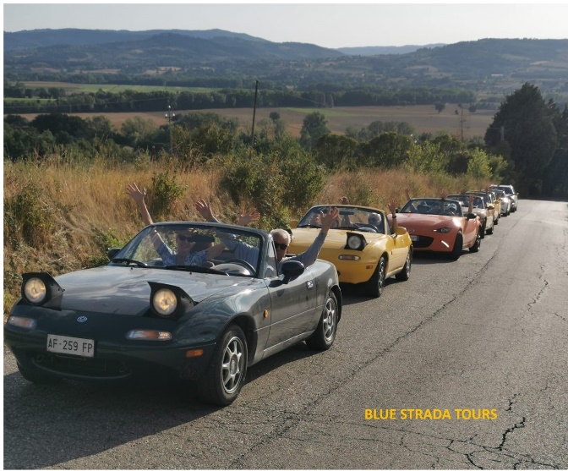
Miata Tuscany Tour Includes:

- A variety of Miata MX-5s (std trans)
- 8-night stay in 4- Star Inns or Hotels
- Tour Support Vehicle
- All Breakfasts
- A ‘Specialty’ Lunch & All Dinners
- Enthusiastic English-Speaking guides
- Airport / Hotel Limo Transfers
- All Taxes
- Primary Insurance on Vehicles
- Commemorative Apparel

The Tour Does NOT Include:
- Flights to Rome ٠ Most Lunches
- Fuel ٠ Travel Insurance
- Personal Expenses
____________________________________________________________________
2024 TOUR PRICING
2 Drivers / 2 Cars / 1 Room 2 people / 1 car /1 Room 1 Driver/ 1 car/ 1 Room
$ 5,195* per person $ 7,875* $ 5,790*
(May 2023) Pricing is good through Dec 1, 2023*
For Reservations Contact: billk@bluestradatours.com, 1 704 292 8801

