***2025 Miata “The Explore Sardinia” Driving Tour***

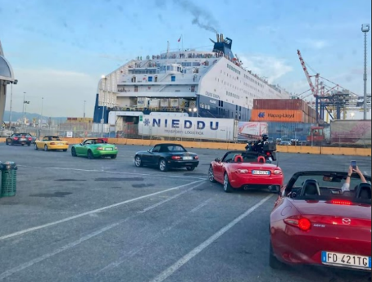 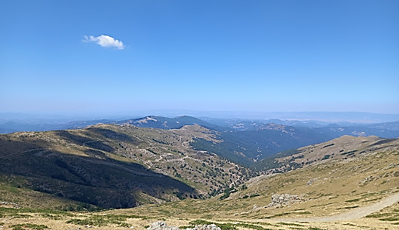

Join us in 2025 for a driving journey to the island of Sardinia. It is now an important part of Italy, but only since late 1800s. Driving the rolling coastline roads and backroads of central Sardinia, we will be able explore the quaint towns of Castelsardo, Porto Cervo, Villasimius, Cala Brandi chi, and the Roman villages of Nora and Tharros.

The Explore Sardinia Tour includes an overnight in the Eternal City of Rome before departing for the scenic roads and rolling hills of Tuscany and then Sardinia. Rest assured; it is an exhilarating driving experience. Enjoying lunches and Italian coffees in small villages along the way will endear you to the rural life and culture that Sardinians are so proud of.

Sardinia is an island that is about 9,000 square miles with spectacular coastline roads to enjoy the views. Small villages and coastal resorts dot the coastline the entire way around…. 1,150 miles of winding, meandering roads with mountains as high as 6,100 feet in the Central region of the island.

Sardinia is so famous for their regional food: ‘Supercheddu’… ‘Culurgiones’…’Malloreddus’…’Spezzatino con Piselli’ and amazing red wines. Join us so you too can discover just how delicious this incredibly special place is.

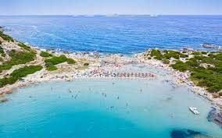 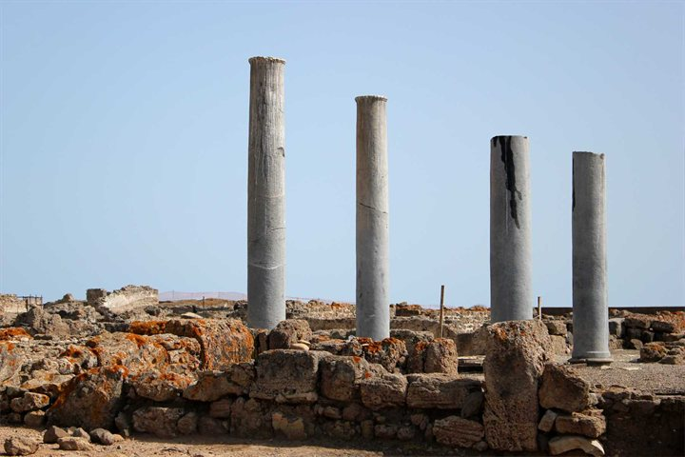

Blue Strada’s experienced Tour Leaders spend a great deal of time locating the best driving routes and hospitality so your motoring excursion will always be remembered with a smile. The Sardinia-Tuscany Amore Tour ends in Rome. Adding more days in Rome at the end of your tour is also a good idea. Our personal assistance is available as needed.

***“The Explore Sardinia” Driving Tour***

**What: 8-Day Miata Driving Tour of Sardinia & Tuscany, Italy**

**Tour Dates: May 17--25; Oct. 18—26, 2025**

**Hospitality: 4-Star Inns with all Breakfasts and Dinners included**

***Day 1:* Arrival at Rome*… typically in the A.M. from North America. Relax at the hotel and enjoy the afternoon in Rome. A “Meet & Greet” with guests and staff in the late afternoon before our ‘Welcome Dinner’ that evening in Rome. \**We do recommend arriving 1-2 Days early to explore Rome and adjust to the new time zone.***

***Day 2:* After breakfast, a van will take us directly to pick up the cars; just the beginning of our first day of driving through Tuscany to arrive in Livorno. From there, we will board a ferry with overnight accommodation to Olbia, Sardinia.**

***Day 3:* Arriving early in the morning at Olbia, our beautiful and exciting drive begins around the northern point of the island before heading south. Hotel / Spa for two nites.**

***Day 4:* A loop drive to an inner island lunch destination is planned before returning to the same hotel.**

***Day 5:* Heading further south along the west coast ending up on the Central of the island.**

***Day 6:* A scenic and exciting drive across the island to an Eastern coast village resort is the plan.**

***Day 7:* Today’s drive along Eastern coast as we return to the port of Olbia for our overnite ferry ride back to the mainland at Civitavecchia.**

***Day 8****:* **Arriving in the A.M. followed by a short drive for brunch before dropping off the cars and getting transported by van to our Rome hotel. Still, allowing guests time to see why Rome is so special. The day in Rome finishes with the ‘Tour Celebration’ dinner.**

***Day 9:* Transport to Rome International airport will begin per guests’ flight schedule.**

**\*\* *Tour details may always change slightly as we make improvements…***

***“The Explore Sardinia” Driving Tour***

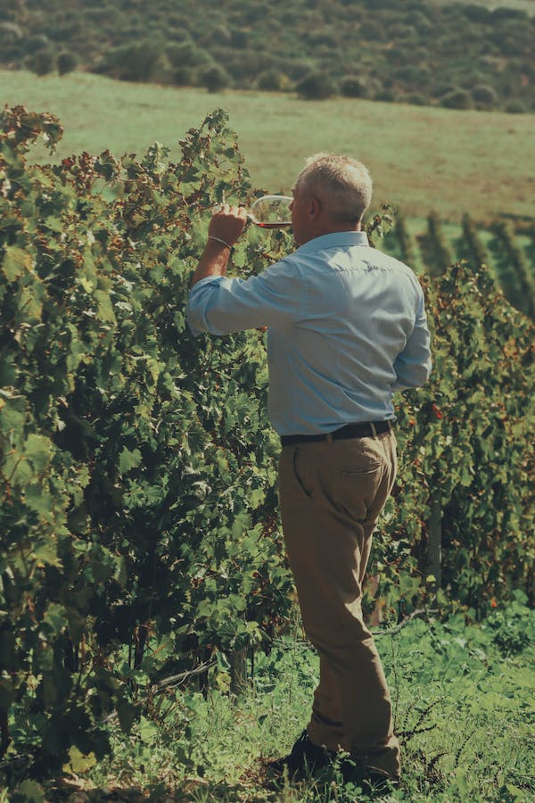

***Miata Sardinia Tour Includes:***

* **A variety of Miata models with standard shift. (A, B, C, D models)**
* **8-night stay in 4- Star Inns or Hotels**
* **Tour Support Vehicle**
* **All Breakfasts & Dinners**
* **Enthusiastic English-Speaking guides**
* **Airport / Hotel Transfers**
* **Primary Insurance on Vehicles**
* **Commemorative Apparel**

***The Tour Does NOT Include:***

* **Flights to Rome ٠ Most Lunches**
* **Fuel & Tolls ٠ Travel Insurance**
* **Personal Expenses**

***____________________________________________________________________***

***2025 SARDINIA TOUR PRICING***

***2 Drivers / 2 Cars / 1 Room 2 people / 1 car /1 Room 1 Driver/ 1 car/ 1 Room***

***$ 5,150* per person $ 8,175* $ 5,875\****

*(8/17/24)* ***Pricing is good through Dec 1, 2024\****

***For Reservations Contact:*** ***billk@bluestradatours.com******, 1 704 292 8801***