***The Amazing Alps of Italy & Switzerland Moto Tour***

***⁓ Including a ‘Special’ visit to the 102-year-old factory of Moto Guzzi⁓***

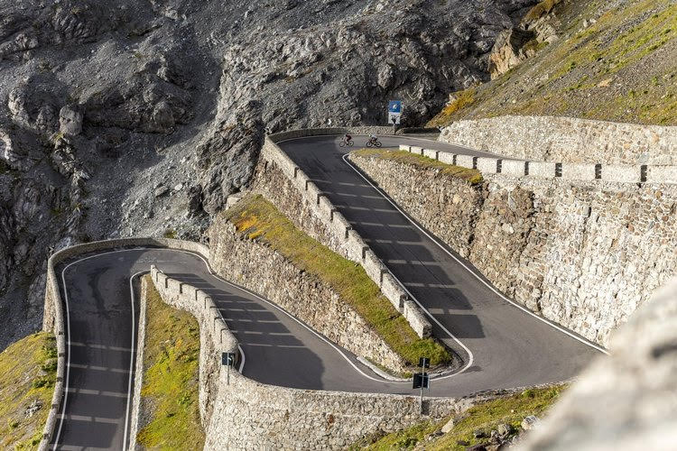 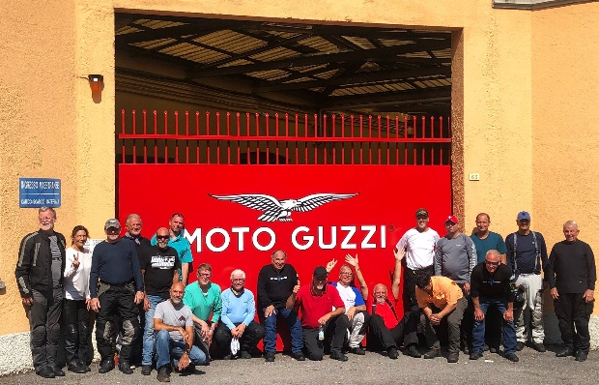

**The Gavia Pass Moto Guzzi, Mandello del Lario**

**What: 9-Day Moto Tour of Alps: 7 days Riding**

**When: July 15--23, 2025**

**Bike Choices: Moto Guzzi, BMW, Honda, Yamaha and Ducati,**

**Hospitality: 4-Star Hotels; All Breakfasts, Dinners & Transfers Included.**

**Prices: Solo riders start at: $4,585 Couples from: $8,750**

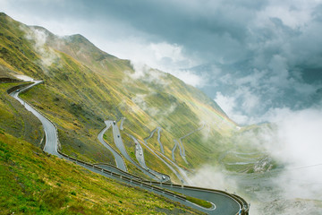

**The Stelvio Pass**

For Reservations, More Details & Any Questions

[billk@bluestradatours.com](mailto:billk@bluestradatours.com) 704.292.8801

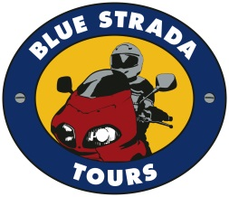

This very special moto-tour to Northern Italy starts in Milano, the Italian capital of Industry, Culture, Business and Fashion. It’s also the threshold to the lakes Lugano, Garda, and Como. The Dolomites and the Alps are just a short distance away and will be a large part of the excitement of this Tour.

**Moto Guzzi Wind Tunnel**

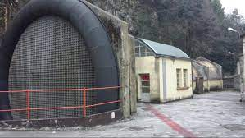

**July 16, 2024**

**Day 1**: Welcome to Milano! Meet new friends including the bike you will rely on for 7 days.

**Day 2**: Milano to the Trentino before arriving in the mountains at Madonna di Campiglio.

**Day 3:** Through the Dolomites UNESCO World Heritage arriving at Pozza di Fassa

**Day 4**: Twisty roads and passes continue to Tirano… next to the Swiss border.

**Day 5:** Next stop Davos, Switzerland. An unusual Ski Resort Town and Political Center.

**Day 6**: The ‘Heart of the Alps’; Andermatt, Switzerland Winter & Summer Destination.

**Day 7**: A ‘Free-Day’ to ride or simply enjoy the village & scenic views from Andermatt.

**Day 8**: Leaving Andermatt via Lake Como and **Moto Guzzi** before arriving Milano

**Day 9**: Depart Milano for home or another adventure.

**The Alps Guzzi Motorcycle Adventure of Lifetime**

**What: 9-Day Motorcycle Tour: The Alps Guzzi Tour**

**When: July 16—24, 2024**

**Hospitality: 4-Star Hotels; All Breakfasts, Dinners & Transfers are Included.**

**Prices: Solo riders start at: $4,785 Couples from: $7,850**

**MOTORCYCLES**

**Early Rez =_Best Choices** **SOLO 2-UP**

**Honda NC750X** **$4,785\***

**Moto Guzzi V7 850 $4,885\***

**BMW F750GS $4,885\***

**BMW F850GS $4,885* $7,850**

**BMW 1300 GS $5,545 $8,185**

**Moto Guzzi V85TT $4,950* $7,850**

**Honda Africa Twin 1100 $5,250* $7,895**

**Ducati Multistrada V2 $5,350* $7,950**

**BMW R1250GS/RT $5,450* $7,950**

**Ducati Multistrada V4 $5,650* $8,275**

***Single Room Supplement $ 725***

***\*Shared Double Room ( Pricing good thru Dec 15, 2024)***

**The Tour Includes:**

Motorcycle with 3 cases • 8 Nights in 4-Star Hotels* • All Breakfasts & Dinners • Airport Transfers • Motorcycle Insurance and All Taxes • Support Van for luggage and shopping • English Speaking Tour Guides • Tour Commemorative Memento.

**The Tour does not Include:**

Flights • Lunches • Personal Expenses • Fuel • Tolls • Travel Insurance • Gratuities

For **Reservations, Details & Questions**:

**Contact:** [**Billk@bluestradatours.com**](mailto:Billk@bluestradatours.com) **• 1-704 292 8801**