***The 2025 Miata ‘Amore’ Tuscany Driving Tours***

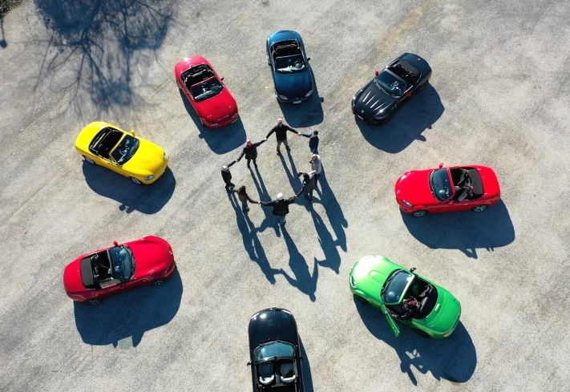

Join ***Blue Strada Tours*** in 2025 for a driving journey into the heart of Italy. Six (6) days driving the rolling backroads of Tuscany and Umbria, with time still to explore the quaint towns of Siena, Orvieto, Montefollonico, San Gimignano, Chianti Region, Orvieto, Todi and more.

The Miata Amore Tours include an overnight in the Eternal City of Rome, several nights in the ‘World Heritage” city of Siena, and three (3) nights just a short distance from Orvieto in Collazzone. The scenic roads and rolling hills of Tuscany, Lazio and Umbria are what connect these amazing cities for eight (8) days. Rest assured; it is an exhilarating driving experience. Enjoying lunches and Italian coffees in small villages along the way will endear you to the rural life and culture that Italy is so famous for.

A 16th century Inn overlooking Siena will be home for three nights while we explore more of Tuscany--including beautiful historic villages and some of the most famous regions for Italian wine.A picture containing text, grass, mountain, nature

Blue Strada’s experienced Tour Leaders have spent many hours organizing the driving routes and hospitality to deliver a motoring excursion you will always remember with a smile. The Miata Amore Tour ends in Rome. Adding more days in Rome at the end of your tour is encouraged and our assistance will be available as needed.

***Amore! The 2025 Miata Tuscany Driving Tours***

**What: 8-Day Miata Driving Tour of Tuscany & Umbria, Italy**

**Tour Dates: May 4-12; June 1-June 8; Sept. 21--29; October 5--13.**

**Hospitality: 4-Star Inns with all Breakfasts and Dinners included**

***Sunday:* Arrival in Rome*… typically in the A.M. from North America. Relax at the hotel and enjoy the afternoon in Rome. A “Meet & Greet” in the late afternoon before our Welcome Dinner that evening in Rome. We s*trongly suggest arriving 1-2 Days early to explore Rome and adjust to new time zone.***

***Monday:* After breakfast, we rendezvous with the Miatas a short distance from Rome. We will take a meandering route through Lazio to a nice lunch overlooking Orvieto. Then on to Umbria where the Abbazia Collemedio Resort is located where we will stay for three nights.**

***Tuesday*: We depart mid-morning through lovely roads in Perugia to Castelluccia di Norcia for a typical Italian lunch with beautiful view, returning on another fun alternate route.**

***Wednesday:* More winding roads to the spectacular city of Assisi with all it’s history and charm..**

***Thursday:* Meet the San Gimignano spirals; a visit to Chianti Region, Brolio Castle and Siena’s** [***Piazza del Campo***](https://www.discovertuscany.com/siena/piazza-del-campo.html)***--a* medieval square in Centre of** [**Siena; famous for 390 years of Palio Horse Races**](https://www.discovertuscany.com/siena/palio-siena.html) **held twice each year.**

***Friday:* Winding roads to the *Chianti Region*; the “roofless” 13th century San Galgano Abbey.**

***Saturday:* More roads to love with a loop drive returning to Siena for an official visit and dinner. The route includes a stop at the hot springs of Bagno Vignoni and a view of the volcano Amiata.**

***Sunday:* Our last ‘meandering’ drive towards the Miata Garage includes a savory stop along the way before boarding the vans and returning to Rome hotel by mid-afternoon; allowing guests more time to see why Rome is so special. The day finishes with the Tour Celebration dinner.**

***Monday:* Transport to Rome International airport will begin per guests’ flight schedule.**

***Amore! Miata 2025 Tuscany Driving Tours***

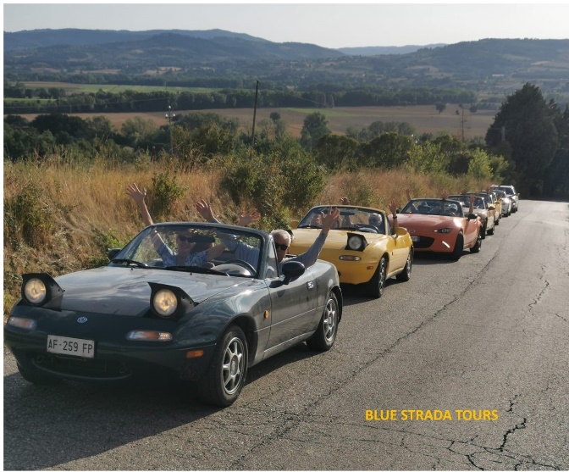

***Miata Tuscany Tour Includes:***

* **4 generations of MX-5s (std trans)**
* **8-night stay in 4- Star Inns or Hotels**
* **Tour Support Vehicle**
* **All Breakfasts & Dinners**
* **A Specialty “Tuscan” Lunch**
* **Enthusiastic English-Speaking guides**
* **Airport / Hotel Limo Transfers**
* **All Taxes**
* **Primary Vehicle Insurance / $3k max.**
* **Commemorative Apparel**

***The Tour Does NOT Include:***

* **Flights to Rome ٠ Most Lunches**
* **Fuel (Est. 200€) ٠ Travel Insurance**
* **Personal Expenses**

***____________________________________________________________________***

***2025 TOUR PRICING***

***2 Drivers / 2 Cars / 1 Room 2 people / 1 car /1 Room 1 Driver/ 1 car/ 1 Room***

***$ 5,395* per person $ 8,175* $ 6,290\****

***2025 Details & Pricing Effective June1, 2024\****

***For Reservations Contact:*** ***billk@bluestradatours.com******, 1 704 292 8801***