**Morocco…A Kingdom of Adventure**

**What: 13-Day Riding Blue Strada Motorcycle Tour: Spain and Morocco**

**When: April 11-24, 2025**

**Hospitality: 4-Star Hotels; All Breakfasts and Dinners. All Transfers Included.**

**Day 1: Arrive Seville**: Seville, Spain is world-renowned for its beautiful architecture, monuments, flamenco, and tapas scene. This Andalusian city oozes a rich history through its quaint neighborhoods, historic churches, and palaces. You will be blown away by the incredible sights Seville has to offer.

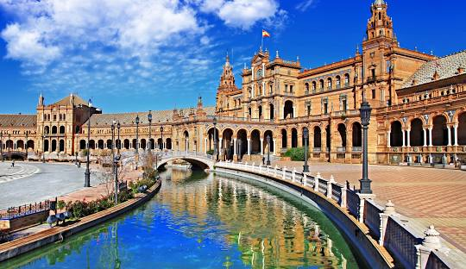

**Day 2: Tangier, Morocco** Located on the Strait of Gibraltar where Africa meets Europe, Tangier has long held strategic importance. Ruled through the centuries by waves of conquerors including Romans, Vandals, Byzantines, Arabs and Portuguese, the city is more than two and a half millennia old, making it one of North Africa's most ancient. The medina, kasbah, bazaars

**Day 3: Casablanca:** a port city and commercial hub in western Morocco, fronting the Atlantic Ocean. The city's French colonial legacy is seen in its downtown Mauresque architecture, a blend of Moorish style and European art deco

**Day 4: Ouzud , Morocco**: The Ouzud Waterfalls are the tallest falls in North Africa. Ouzoud Waterfall is a collective name for several tall waterfalls that empty into the El-Abid River gorge 330 feet below.

**Day 5: Ouzoud to Marrakech, Morocco**: Known for its beautiful palaces and museums, and its bustling ‘souks’ (markets) and traditional hammams (bath houses). Marrakesh, famous for the Bahia Palace,

**Day 6: Marrakech: Free Day…** Marrakech a city of luxury, thanks to its famous palaces, 5-star restaurants, luxury spas and charming riads (traditional houses) in the medina. Amongst others, the luxurious Royal Mansour hammam and the refined cuisine of Namaskar Palace. Even a desert trek in a Quad or Hot-Air Balloon are among the many activities available in Marrakech. A moto-ride 4 sure too.

**Day 7: Marrakech to Boumalne du Dades**:  **Boulmane** **Dades** is a beautiful backdrop of adobe houses and brightly hued rocky cliffs in the Atlas Mountains; it's a rich cultural and historical hub in the country.

**Day 8: Boumalne du Dades to Merzouga: 250 km**

**Day 9: Merzouga**: A Free Day to bask in glorious sunsets and channel your inner sheik while you ride a meandering camel across the windblown dunes of Erg Chebbi. Moto ride is optional. Expand your appreciation for resilient 4×4; visit the Moroccan National 4×4 Auto Museum in Merzouga. Discover the wide range of vehicles that have been used since the 1900s to cross the desert. Learn about the cars and their roles – including transporting the Moroccan king!

**

**Day 11: Aguelmam Lake** is a natural lake located east of the city of [Khenifra](https://fr.wikipedia.org/wiki/Kh%C3%A9nifra" \o "Khenifra) in [Morocco](https://fr.wikipedia.org/wiki/Maroc) , about twenty kilometers as the crow flies. Located in the large cedar forest of [Ajdir n-Izaïane](https://fr.wikipedia.org/wiki/Ajdir_Izayane" \o "Ajdir Izayane) , it is part of the [Khenifra National Park](https://fr.wikipedia.org/wiki/Parc_national_de_Kh%C3%A9nifra" \o "Khenifra National Park) .

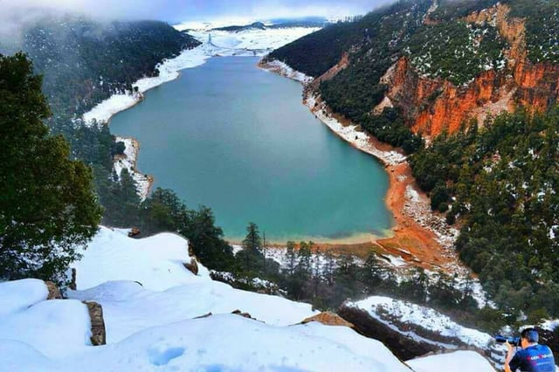

**Day 12: Fez, Morocco:** Fez, Morocco is famous for their medina, a massive community of small cobblestone alleys loaded with riads, Moroccan lodging, as well as souks, which are Arab marketplace vendors. It is home to the oldest Medina in the whole wide world and is a UNESCO World Heritage Site.

**Day 13: Chefchaouen:** is a city in northwest Morocco. It is the chief town of the province of the same name and is noted for its buildings in shades of blue, for which it is nicknamed the "Blue City". A photographer’s dream. Then we will travel on towards Tangier and finally Seville.

**Day 14: Departure from Seville home or your next adventure. 🛫**

**__________________________________________**

**MOTORCYCLES**

**Early Rez =_Best Choices** **SOLO 2-UP___**

**Honda: CB 500X / NC 750X** $7,525*

**BMW 750 GS** $7,675* $10,950

**Yam Ténéré 700/**  $7,675* $10,950

**Honda 750 Trans Alp** $7,675*$10,950

**Hus 901/ BMW GS 1300** $7,975* $11,550

***Single Room Supplement $ 925 *Shared Double Room (Rev. 10 Dec. 24) Pricing good through Jan 30, 2025***

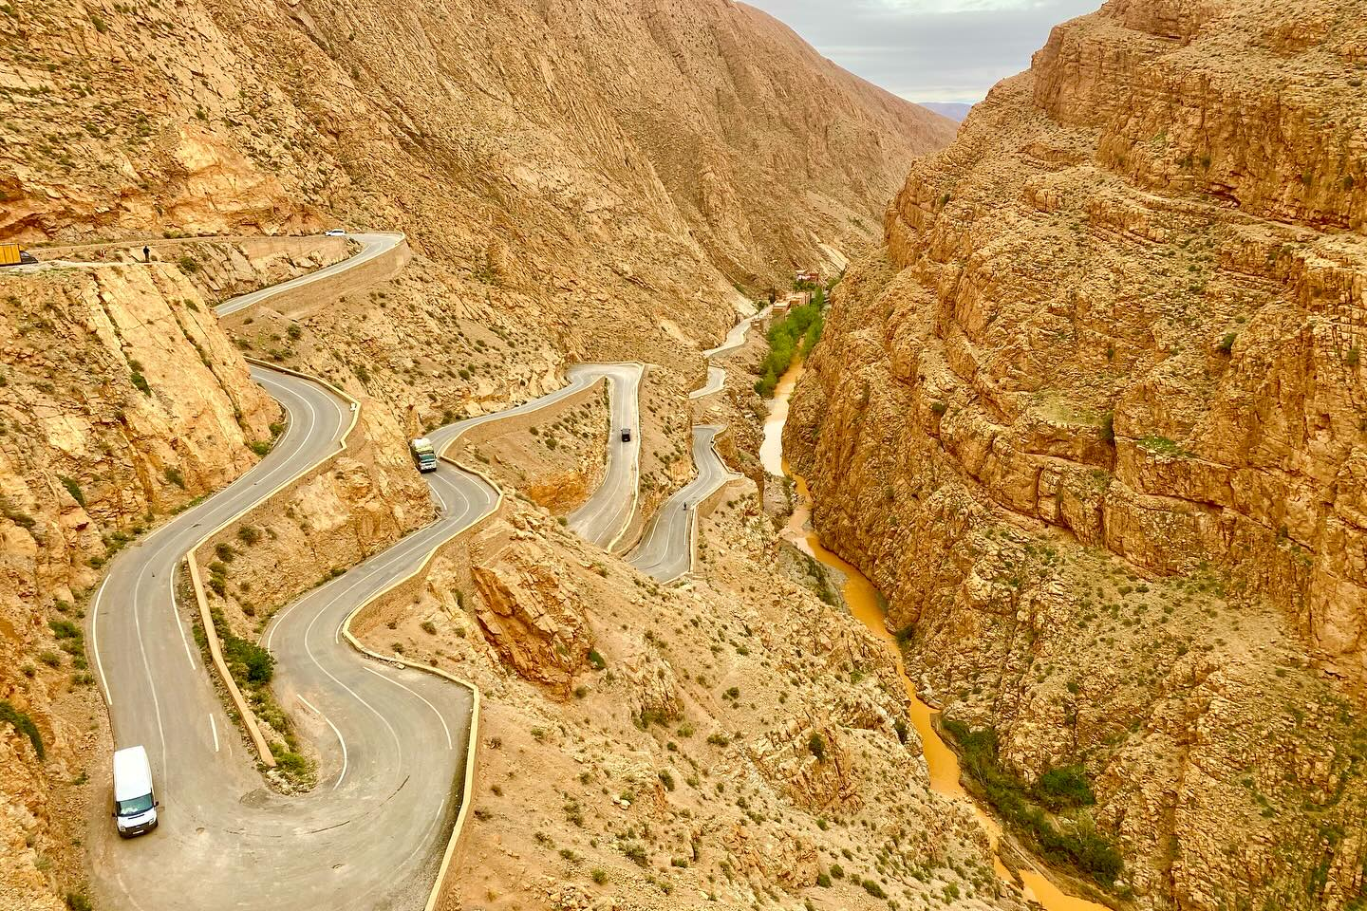

**The Tour Includes:**

Motorcycle with 3 cases • Fuel • 13 Nights in 3-4-Star Hotels* • All Breakfasts & Dinners • Airport Transfers • All Motorcycle Insurance Spain & Morocco • All Taxes • Support Van for luggage • English Speaking Tour Guides ٠ Tour Route Book • Tour Commemorative Gear • Guided Tour Marrakech & Fez

**The Tour does not Include:**

Flights • Lunches • Personal Expenses • Travel Insurance • Gratuities

For more Details & questions:  **Contact:** [**Billk@bluestradatours.com**](mailto:Billk@bluestradatours.com) **• 1-704 292 8801**