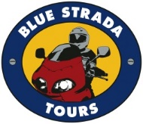

***“Let’s Explore Sardinia” Motorcycle Tour…*2025**

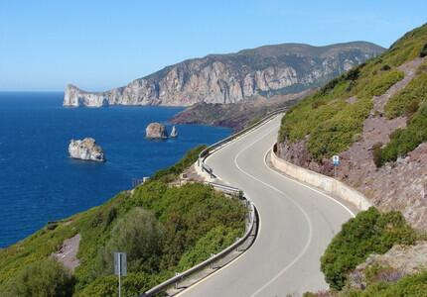 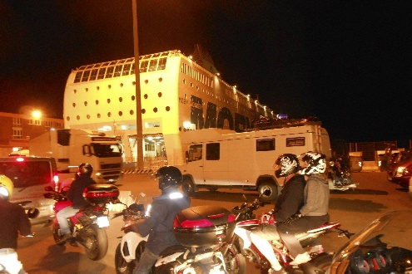

Join us in 2025 for a two-wheeled journey to the island of Sardinia. It is now an important part of Italy, but only since late 1800s. Driving the rolling coastline roads and backroads of central Sardinia, we will be able explore the quaint town of Alghero, and the prehistoric, incredible village of “Su Nuraxi” in Barumini, an amazing UNESCO site.

The Explore Sardinia Tour includes an overnight in the Eternal City of Rome before departing for the rolling hills of Tuscany and then Sardinia. Rest assured; it is an exhilarating riding experience. Enjoying lunches and Italian coffees in small villages along the way will endear you to the rural life and culture that Sardinians are so proud of.

Sardinia is an island that is about 9,000 square miles with spectacular coastline roads to enjoy the views. Small villages and coastal resorts dot the coastline the entire way around…. 1,150 miles of winding, meandering roads with mountains as high as 6,100 feet in the Central region of the island.

Sardinia is so famous for their regional food: ‘Culurgiones’…’Malloreddus’…’Seadas’ and amazing red and white wines.😁. Join us to discover just how wonderful this special place is.

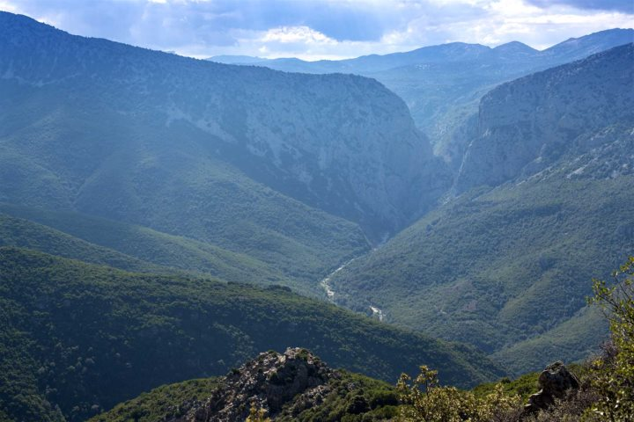 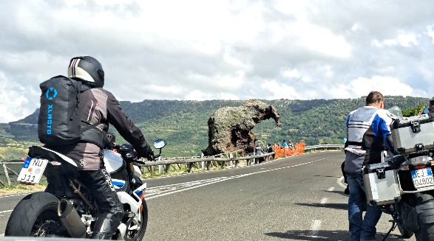

Blue Strada’s experienced Tour Leaders spend a great deal of time locating the best driving routes and hospitality so your motoring excursion will always be remembered with a smile. The “Let’s Explore Sardinia” Motorcycle Tour ends in Rome. Adding more days in Rome at the end of your tour is also a good idea. Our personal assistance is available as needed.

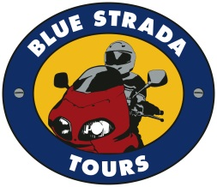

***“Let’s Explore Sardinia” Motorcycle Tour for 2025***

**What: 8-Day Motorcycle Adventure of Sardinia & Tuscany, Italy**

**Tour Dates: Sept 21--29, 2025**

**Hospitality: 4-Star Inns with all Breakfasts and Dinners included**

***Day 1:* Arrival at Rome*… typically in the A.M. from North America. Relax at the hotel and enjoy the afternoon in Rome. A “Meet & Greet” with guests and staff in the late afternoon before our ‘Welcome Dinner’ that evening in Rome. \**We do recommend arriving 1-2 Days early to explore Rome, recover from an overnight flight (typically) and adjust to a 5-8 change in the time zone.***

***Day 2:* After breakfast, we go directly to pick up the bikes; just the beginning of our first day of driving through Tuscany to arrive in Livorno. After dinner in Livorno, located on the west coast, we will board a ferry with overnight accommodation to Olbia, Sardinia.**

***Day 3:* Arriving early in the morning at Olbia, our exciting ride begins crossing the amazing “Emerald Coast” to the northern point of the island before heading south to Alghero and a beautiful hotel / Spa for two nites.**

***Day 4:* An exciting loop ride to an inner island destination before returning to our same hotel. Further excitement is planned for the afternoon that everyone loves!**

***Day 5:* Continuing south along the twisty west coast road to the Bay of Santa Caterina.**

***Day 6:* A scenic, yet very exciting drive across the island to a magnificent east coast resort, with visit of the “Su Nuraxi” prehistorical UNESCO site.**

***Day 7:* Riding the incredible Canyon Gorropu - the longest canyon in Europe - in the direction of Olbia for +145 km is something that will not soon be forgotten. Our dinner is in Olbia before boarding the ferry back to Civitavecchia.**

***Day 8****:* **Arriving in the A.M. followed by a nice ride to lunch before returning the bikes in Rome. Still, plenty of time to see more of why Rome is so special. The day in Rome finishes with one more fantastic dinner… to celebrate a memorable and fun week.**

**\*\* *Tour details may always change slightly as we make improvements…***

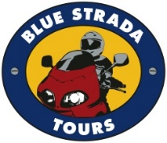

***“Let’s Explore Sardinia” Motorcycle Tour***

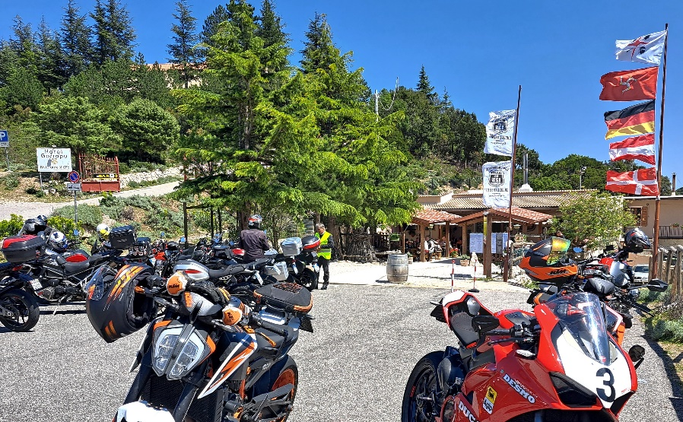

***Explore Sardinia Moto-Tour Includes:***

* **A variety of motorcycle models**
* **6-night stay in 4- Star Inns or Hotels**
* **2 overnights on ferry; private cabins**
* **Tour Support Vehicle**
* **All Breakfasts & Dinners**
* **Gasoline for motos.\*\***
* **Enthusiastic English-Speaking guides**
* **Airport / Hotel Transfer on arrival**
* **Primary Insurance on Vehicles**
* **Commemorative Apparel**

***The Tour Does NOT Include:***

* **Flights ٠ Lunches**
* **Personal Expenses ٠ Travel Insurance**

** *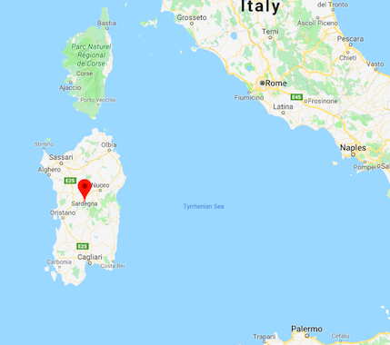***

***2025 Explore Sardinia… Moto-Tour Prices***

**MOTORCYCLES**

**Reserve Early for Best Pick** **SOLO 2-UP**

**Honda NC750X** **$4,785\***

**Moto Guzzi V7 850 $4,885\***

**BMW F750GS $4,785\***

**BMW F850GS $4,985* $7,650**

**Moto Guzzi V85TT $4,950* $7,650**

**Honda Africa Twin 1100 $4,850* $7,695**

**Ducati Multistrada V2 $4,950* $7,650**

**BMW R1250GS/RT $4,950* $7,950**

**BMW 1300 GS $5,245* $7,950**

**Ducati Multistrada V4 $5,350* $7,950**

**\*Shared Rm / *Single Rm Supplement $ 685***

***\*\*Pre-paid Gasoline expense of $165 will be added to final invoice***

*(1/25)* ***Pricing is good through March 30, 2025\****

***For Reservations Contact:*** ***billk@bluestradatours.com******, 1 704 292 8801***